**Exercise 8**

**Illuminating Photosynthesis**

**Purpose**

The purpose of this laboratory is to characterize the principle photosynthetic pigments for a better overall understanding of this complex biochemical process.

**Lab Objectives:**

After completing this lab, students should be able to

1. Isolate and identify the light-harvesting pigments of Photosystems I and II.
2. Determine the absorption spectrum of these pigments.

**Introduction**

Photosynthesis is arguably the single most important metabolic pathway, as it converts solar energy into the chemical energy used to reduce CO2 to glucose, the fuel that powers most life on Earth. Clearly, this complex pathway consists of two distinct stages.

During a two-step electron transport process, the Light Reactions consist of photon harvest by chlorophyll and carotenoid pigments and their subsequent conversion into ATP and NADPH. Known as the Hill Reaction, the source of electrons for transport is the lysis of water. The remaining hydrogen ions will generate a gradient across the thylakoid membrane to permit the chemiosmotic production of ATP while the leftover oxygen proves a valuable byproduct for aerobic organisms.

The extremely endergonic or energy consuming reduction of CO2 is driven by the ATP and NADPH generated in the light reactions. Because this stage is only indirectly dependent on light, it is called the Dark Reactions.

Although this lab will analyze only the light reactions of photosynthesis in this experiment, remember that both light dependent and independent processes are essential for the solar-powered production of glucose.

**Procedure**

**Isolation, Identification, and Absorption Spectra of the Principle Photosynthetic Pigments.**  Paper chromatography is a quick, simple pigment separation method. You will need the following materials from the front bench:

* A strip of chromatography paper 6.0 cm wide and trimmed to fit chamber.
* Chromatography chamber with lid and hook.
* ~25 ml chromatography solvent **(NOTE: Highly Flammable!).**
* 3 g deveined spinach, pinch of sand, 15 ml chilled acetone, and mortar and pestle.
* Pasteur pipette, 15 ml centrifuge tube, capillary tube, and paper towel.

Scissors, mm ruler, tt rack with 5 capped tubes + 4 cuvettes.

*Extraction*

Step 1: Tear spinach into small pieces and place into a chilled mortar with 15 ml of ice cold acetone and a pinch of sand.

Step 2: Grind the leaves thoroughly for 1 minute with a chilled pestle.  **(NOTE: Acetone is also flammable.)**

Step 3: Transfer the liquid and pulp to the capped centrifuge tube.

Step 4: Shake vigorously for 10 sec and place in the refrigerator for 10 min. During this time, the pulp will settle and additional pigment will be extracted from it.

*Chromatography*

Step 1: With a pencil and a ruler, draw a line across the width of your chromatography paper about 3 cm from the bottom. The extract will be applied to this site (origin) and it must **not** be immersed in the solvent.

Step 2: Using a capillary tube, streak at least 10 applications of the pigment extract along the line. The capillary tube is filled by immersing the tip in the extract. The flow from the capillary tube is controlled by finger pressure at the top. Allow each application to dry before making the next. Gentle blowing will facilitate the process. The final thickness of the streak should be no more than 6-7 mm.

Step 3: Dispose of the excess acetone from your extract in the labeled container.

Step 4: Attach the streaked chromatography paper to the chamber lid and insert into the equilibrated chamber being careful to adjust the solvent volume so that it does not directly contact the streak.

Step 5: Allow the chromatogram to develop for 15-45 min. Check the progress of your chromatogram at 10 min intervals.

Step 6: Stop the development when the solvent front reaches approximately 3 cm from the top of the paper.

Step 7: Remove the chromatogram from the chamber and hold by the top corner until dry.

Step 8: Using a pencil, mark the solvent front and the center of each band. Record the requested information in the data Table 1.

*Absorbsion Spectra of Photosynthetic Pigments*

Step 1: Label 4 capped test tubes as follows: chlorophyll b, chlorophyll a, xanthophylls, and β-carotene.

Step 2: Cut out each of the four bands and place each in the appropriately labeled tube. Place the 2 xanthophylls in the same tube (violaxanthin and lutein). To facilitate elution of the pigments, you may wish to cut each band into several very thin strips.

Step 3: Add 4 ml of acetone to each tube and seal. **(Note: Remember that acetone is flammable.)**

Step 4: Allow the pigments to elute for 5 min, occasionally swirling the tubes. Invert the tubes several times to thoroughly mix the contents.

Step 5: Pour the pigment solutions to appropriately labeled cuvettes with a pipette.

Step 6: Using the spectronic 20 and the indicated wavelengths, determine the absorption spectrum for each of your eluted pigments. The spectrophotometer must be calibrated with the blank at each wavelength.

Step 7: Record this information in data Table 2.

**Data Table 1.** Chromatogram Data

|  |  |  |  |  |
| --- | --- | --- | --- | --- |
| **Pigment** | **Color** | **Solute distance (mm) from origin** | **Distance of solvent front (mm)** | **Rf** |
| Chl b |  |  |  |  |
| Chl a |  |  |  |  |
| Violaxanthin |  |  |  |  |
| Lutein |  |  |  |  |
| β-Carotene |  |  |  |  |

**R(f) values** are a measure of the rate of chromatographic component migration and thus indirectly a determination of component solubility within a given solvent. An R(F) value of 0.5 means that the component travelled 50% of the distance that the solvent moved. Calculate the pigment R(F) values for your chromatogram by measuring the distance travelled (in mm) by each pigment and dividing it by the distance travelled by the solvent front. For a given solute and solvent at a specific temperature, this value is a constant.

**Data Table 2.** Absorbance Readings for Chl b, Chl a, Xanthophylls and β-Carotene.

|  |  |  |  |  |
| --- | --- | --- | --- | --- |
| **Wavelength (nm)** | **Chlorophyll b** | **Chlorophyll a** | **Xanthophylls** | **-Carotene** |
| 400 |  |  |  |  |
| 410 |  |  |  |  |
| 420 |  |  |  |  |
| 430 |  |  |  |  |
| 440 |  |  |  |  |
| 450 |  |  |  |  |
| 460 |  |  |  |  |
| 470 |  |  |  |  |
| 480 |  |  |  |  |
| 490 |  |  |  |  |
| 500 |  |  |  |  |
| 510 |  |  |  |  |
| 520 |  |  |  |  |
| 530 |  |  |  |  |
| 540 |  |  |  |  |
| 550 |  |  |  |  |
| 560 |  |  |  |  |
| 570 |  |  |  |  |
| 580 |  |  |  |  |
| 590 |  |  |  |  |
| 600 |  |  |  |  |
| 610 |  |  |  |  |
| 620 |  |  |  |  |
| 630 |  |  |  |  |
| 640 |  |  |  |  |
| 650 |  |  |  |  |
| 660 |  |  |  |  |
| 670 |  |  |  |  |
| 680 |  |  |  |  |
| 690 |  |  |  |  |
| 700 |  |  |  |  |

**Questions:**

1. What do the Rf values indicate about the relative solubilities of the pigments in the water and solvent phases?
2. Explain the relative solubilities of chlorophyll a and chlorophyll b in the water and solvent phases on the basis of molecular structure.
3. Using the data collected in data table 2, plot the absorbance spectra for chlorophyll a, chlorophyll b, xanthophylls, and β-carotene. At what wavelengths is absorption a maximum for each of the various pigments?
4. Why is having different absorbance profiles important for different pigments that participate in the light reactions of photosynthesis?



Figure 1. Molecular structure of the pigments observed in chromatography

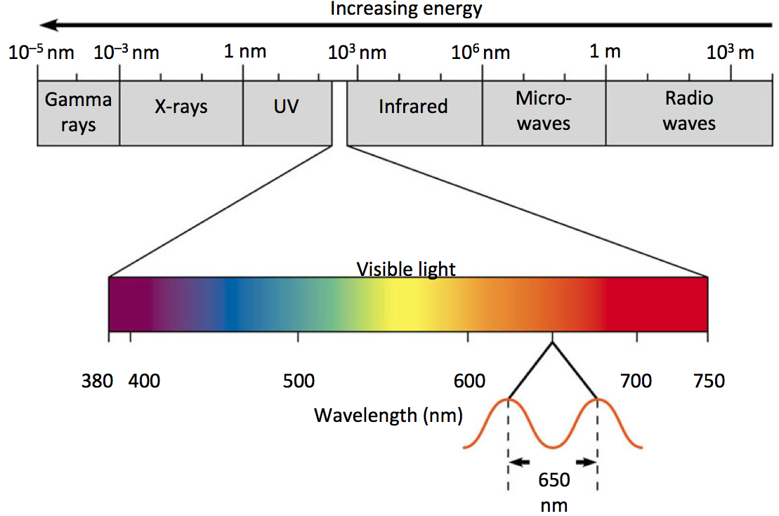

Figure 2. Electromagnetic spectrum

